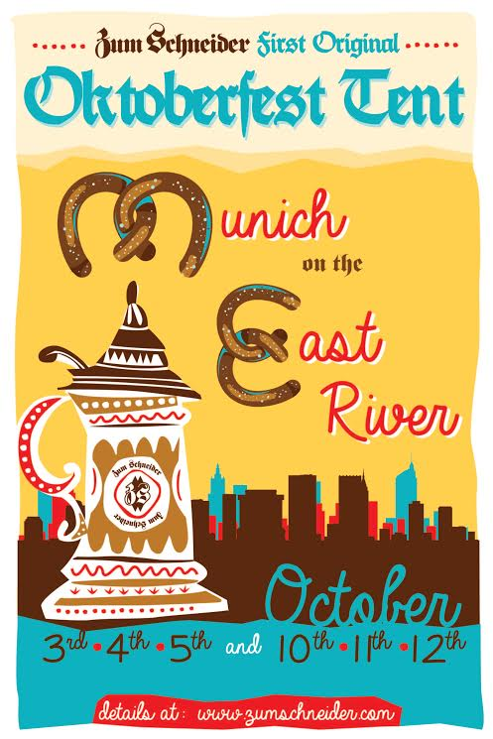
Zum Schneider Presents Munich on the East River
The Largest Oktoberfest Celebration to occur in New York City ever
October 3rd-5th and October 10th-12th, 2014

New York, September 8, 2014—Zum Schneider, the prominent Bavarian Bierhaus in NYC owned by Sylvester Schneider, presents Munich on the East River an unforgettable and traditional München Oktoberfest experience. Zum Schneider hosts its annual event this year in epic proportions, by following the age old traditions of Oktoberfest typically celebrated in Munich for over 200 years.

Sylvester Schneider, owner of Zum Schneider, states, “The intention is to create an atmosphere that comes as close as possible to a traditional Munich Oktoberfest tent on the "Wiesn". Decorations, furniture, beer, food menu complete with German cuisine, and a live Oompah band with Moesl Franzi and the JaJaJas all have been carefully selected for this unique occasion. We want to transport our guests to Munich for an evening.”
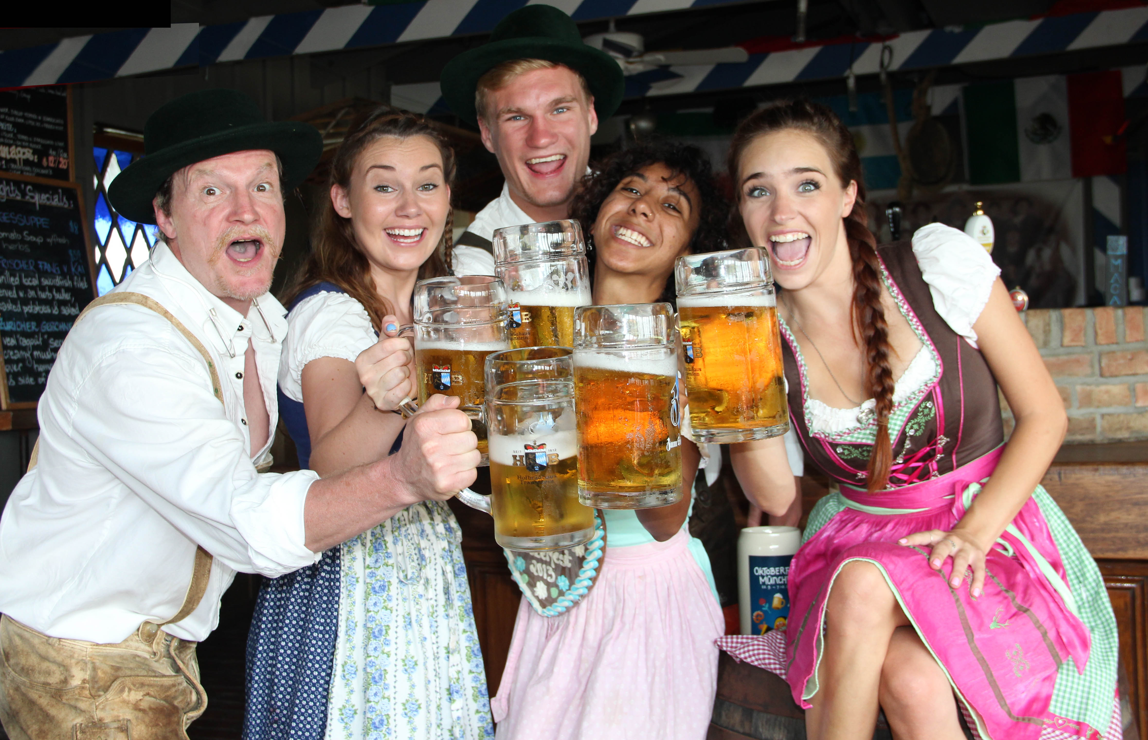
The Bavarian tradition of drinking beer from a stein has been a part of beer festivals around the world and at this year’s Munich on the East River, guests will have the opportunity to walk away with their very own stein decorated with Oktoberfest artwork, which is included in the ticket price.

Zum Schneider’s Oktoberfest will be the first ever large scale, under-a-tent celebration of this great tradition to come to New York City. While many smaller versions have taken place over the years, Zum Schneider promises to be the real thing and welcome all those who wish to celebrate German beer, food, music and culture.

Zum Schneider’s Oktoberfest is a family-oriented event. Activities include a small fair featuring “Hau den Lukas” "Wettnageln" (strong men contests), as well as cotton candy stands, roasted almonds, giant Pretzels, and the traditional gingerbread hearts and more! As Zum Schneider has the reputation for staging authentic Oktoberfest celebrations, this year’s edition will surpass all others in the tri-state area.

Located along the East River and East 23rd street, the original Oktoberfest tent has a capacity to hold almost 1000 people. The service staff are all German speaking and will be dressed in traditional Dirndl and Lederhosen. Original Oktoberfest beers on tap and Wiesn-Hendl & Haxn (Oktoberfest roast chicken & pork shank) and other popular German dishes will be served in the tent.

Munich on the East River will take place from October 3rd-5th and October 10th-12th at 4:00pm-10:00pm on Fridays and 12:00pm-10:00pm on Saturdays and Sundays at Solar One (24-20 FDR Drive Service Road East at the East River and 23rd Street, New York, NY 10010).
We hope you will come and join us for this amazing event—you don’t even need your passport to enjoy this München experience!

Individual tickets purchased prior to September 19, 2014 are $25.00, Group tickets $22.50, and VIP $100.00. Please use the following link in order to purchase tickets: http://bit.ly/1pUfMLP -

Press Contacts:
Sally Fischer Public Relations
Virginia Cademartori, Virginia@sallyfischerpr.com
Samantha Rowe, Samantha@sallyfischerpr.com

About Zum Schneider
Zum Schneider opened its Bavarian doors 14 years ago out of interest to establish a traditional German Biergarten in Manhattan. The owner, Sylvester Schneider felt homesick and longed for his traditional German beer, thus sparking the idea to establish Zum Schneider. This Bavarian indoor Biergarten is home to traditional German Biergarten furniture, authentic food, quality service, exclusive beers from Bavaria and German speaking staff. Zum Schneider guarantees a genuine German experience. Authenticity and culture are the forces behind the events, shows and festivals they host for their customers all year round. Zum Schneider expanded in 2012, and opened its second location in Montauk, Long Island. Zum Schneider also was the sole operator and organizer of the Open Air screenings during the world cup 2014 at the Solar One location by the East River that held up to 2,000 people per event (6 events). http://nyc.zumschneider.com/

